SECTION A: PERSONAL DETAILS
NAME OF STAFF | RUTH WASHINGTON
NAME OF UNIT: | RGPI
REPORTING PERIOD: | JULY WEEK 5

SECTION B: REPORT
SN | KEY RESULT AREA | KEY PERFORMANCE INDICATOR | ACHIEVEMENT FOR THE REPORTING PERIOD | PERFORMANCE MGT SCORE
KRA 1: | Group Pastors Engagement | - Engagement of 200 Group pastors via call to drive sponsorship with multiple wonder & Campaigns  - 2 communications via RGPI handle daily to drive 4 million copies sponsorship | Weekly Engagement Report  (July Week 5)  I office strategic engagement in July week 5, produced tremendous result in sponsorship, the call engagement was an interactive engagement that moves over 84 groups to action  I engaged over 600 groups through KC call, phone call chat/sms and reached 416 Groups in 62 zones across the 5 regions, pushing all the groups towards getting into the league and moving levels leveraging on 17 steps of glory 12 wonder strategy crusades sponsorship, campaigns, to clinch their 4 million copies mandate.  As a result of this engagement, 8groups entered the league, 3 Groups moved levels to silver category, and 4 groups have entered the league as of today 1st of August pushing towards their first 1 million copies before the end of August.  we achieved 8 wonders from 6 groups as a result of the engagement and 56 partners from 17 groups started rhapsody wonder bank, we are expecting over 35 groups and more plus movement in the league this week as a result of the engagement as we continue to push for more  - Monday strategic engagement focused on customized status card leveraging on 12 wonders to change levels in the league  - Tuesday focused on campaign sponsorship/advantage of the 50% offer on digital offer, to enter the league, for the groups yet to enter league  - Wednesday focused on mobilization of the group pastors for stakeholders meeting  - Thursday focused on 12 wonder strategy to your next level/publicity to drive for maximum attendance of the group pastors for the combined stakeholders meeting  - Engaged the group with the status card to push for the next level in week 9  Daily Reach  - Monday, I engaged 103, and reached 49 groups  - Tuesday, I engaged 305 this includes kc chat, and calls and reached 299 groups with feedback  - Wednesday, I engaged 0ver 600 this includes kc chat, sms and phone calls and reached 509 groups  - Thursday, I engaged over 600, and reached 509 groups  - Thursday 499 groups were engaged 407 was reached  Number of Groups Engaged per Region  Region 1: 40 groups engaged in 6 Zones  Region 2: 39 groups engaged in 6 Zones  Region 3: 195 groups engaged in 17 Zones  Region 4: 201 groups engaged in 20 Zones  Region 5: 84 groups engaged in 8 Zones
KRA 2: | Group Pastors Meeting | - To drive 100% attendance  - Engage and Confirm pastors to be on set  - Publicity of the stakeholders meeting to over 600 group pastors via KC, Email, sms and call  - Collaborate with the media for execution of the meeting  - Make post on RGPI handle during the meeting  - Collaborate with the media for execution of the meeting  - Prepare Attendance per region | I pan and executed the 17 edition of groups pastors stakeholders meeting with director  I started mobilizing for the meeting on Tuesday, we engaged over 600 groups through rgpi handle/ their individual kc handle on Tuesday, Wednesday and Thursday for maximum attendance,  - I write to 6 group pastors expected to be on set, physically and virtually  I engaged the 6 pastors to confirmed if they have received their letter and to confirmed their availability  - Follow up to ensure the pastor connect on time  - Follow up to ensure the pastor to be physically on set arrives the studio on time  - I sent out 6 meeting notification cards and 6 reminders notification chat  - Sent out notification through mail  - Sent out thank you card to the pastors individually for participating  - I Prepare attendance per region with total of 317 group pastors and 101 church pastors in attendance  - We had 5 group pastors on set, with so many inspiring and impactful testimonies  Pastor Joseph Atibi brown said he will do over 100 crusades  Pastor Ore Esedebe said will have over 100 crusades  Pastor Ebele Uzodike said he will have over 300 of crusades  Pastor Kingnewman Ezekiel said he will have 300 crusades  Pastor Cyril Ogude said he will have 300 crusades  kindly see the breakdown of group pastors in attendance per region,  Region 1 - 35 group pastors in attendance  Region 2 - 23 group pastors in attendance  Region 3 -116 group pastors in attendance  Region 4 - 106 group pastors in attendance  Region 5 –37 group pastors in attendance  Send out Rebroadcast notifications to over 600 group pastors for those who participated to re-live moment again for action and those who missed to participate leveraging on the rebroadcast
 | WEEK 10 CHAMPIONS LEGAUE |  | 12th Episode of the Champions League 3.0 this week  This week, in preparation for the 12th edition of the champions league: I sent out champions league card on all the groups sent out 4 notification and reminder on champions update for the week through central on the group, collate list on the league for the week and package the champions league from the regions and delivered  I updated the champions league Document, prepare summary per region showing no of groups, how many in the league and how many yet to enter the league and a table summary showing champions in various milestone per region  we have 15 new entries into the league and 6 movements to the next level; 22 groups were celebrated this week both in category A&B  10 groups entered ruby category  5 groups entered silver category in category B group  1 group entered gold category in category B group  2 groups moved level into silver category  1 group from campus ministry cinch to diamond category  1 group moved level to silver category in category A group  1 group moved to diamond gold category in category A group  1 group moved to higher level into Double Diamond Category in category A group  We currently have a total number of 101 groups in the league across category A and B. The breakdown is as follows and still counting  - Category A: 36 groups  - Category B: 65 groups  3 Double Diamond  1 Diamond gold  1 Double Diamond Silver  7 Diamond  5 Gold  21 Silver  63 Rubies.  Number of champions produced by each region this week:  Region 1– 3 new champions  Region 2 – 5 new champions and 3 movements in silver and diamond category  Region 3 – 3 new champions  Region 4 – 3 new champions and 3 movements in double diamond, diamond gold and silver category  Region 5 – 1 new champion
KRA 3: | THE 17 STEPS OF GLORY TO 4 MILLION | - To have 100% percent of the scorecards deployed by all the 5 regions | I engaged the 5 regional Admin for week 8 engagement of the groups with Their status card deployment, acknowledgment and one-on-one engagement on the 17 steps of ever-I increasing glory to 4M  I send reminder message to each regional Admin every  3 hours from Friday to Wednesday for Updates, i  collate and published update on the group  Breakdown achievement across the 5 regions in week 8  Total number of Groups – 648  Total number of status card deployed -648  Total number that acknowledged – 289  Total number engaged 0ne-on-0ne -405  Total response - 594
 | REGION 4 RGPI |  | - I engaged 5 region 4 rzm for their sponsorship records collate and update their current and next level send to our group for the attention of region 4 graphic person  - I deployed 201 status cards to the group pastors through their individual kc handle with their statement attached  - Called 198 group pastors for further engagement from Friday – Wed  - Send personal sms to 201 group pastor to draw their attention to their kc chat for their acknowledgment of the deployed status card on kc  - I achieved 96 acknowledgments, as a result of this strategy and  - As a result of this engagement, we celebrated 3 new groups in the league this week
 |  |  | - I Prepare rgpi monthly report and submitted
- Travelled to Akure to represent the department at the Esteemed pastor Yinka Ezire 50th birthday
- Engaged the group pastors and partners in her zone after the celebration, I encourage them to make up for copies left for her to enter the league as a gift to enterally mark her golden and Deacon Kehinde gave for a wonder immediately and the group pastors promise to make it happen
 |  | TOTAL SCORE |  | 80%

SECTION C: FEEDBACK
COMMENT FROM PERFORMANCE MGT TEAM | COMMENT FROM THE HOP | DATE
You were intentional with all your executions. However, Clearly state your achievement in a simpler way. So that it can clearly be understood

SECTION A: PERSONAL DETAILS
NAME OF STAFF | Pastor Godswill Uka
NAME OF UNIT: | Youths Aglow Media
REPORTING PERIOD: | 5th week of July

SECTION B: REPORT
SN | KEY RESULT AREA | KEY PERFORMANCE INDICATOR |  | ACHIEVEMENT FOR THE REPORTING PERIOD | PERFORMANCE MGT SCORE
KRA 1: | YOUTHS AGLOW SHOW | - To deliver new episode for the program |  | - I successfully produced script for youths aglow show  - I successfully recorded and produced the youths aglow show  - I successfully ensured that Youths Aglow show was aired on Rhapsody TV and Youths Aglow website  Through the Youths Aglow Show, we had viewership of 213,321 participant this week  Kindly see pictures of the Live show below. | Set targets for viewership growth, engagement rates, content quality scores
KRA 2: | ENGAGEMENT DEPARTMENTAL GRAPHICS | Deliver edit as requested |  | we edited and produced 10 videos,  Kindly See the links below; | Was there no time frame and quality metrics?
KRA 3: | Studio / control room operations |  |  | - Mixed visual and produced cards for 2-3 hours on Tuesday for Rhapsody Partnership Managers meeting  - Mixed visuals and produced cards for 2 hours on Tuesday for Regionalized Stakeholders meeting  - Mixed visuals and produced cards for 2-3 hours on Thursday for the zonal pastors stakeholders strategy meeting with the director  - Mixed visuals and produced cards for 2 hours on Thursday for the Group Pastors Stakeholders Strategic Meeting with the Director  - Mixed Visuals and produced cards for 1 hour on Saturday for the Cell Leaders Strategic meeting with the Director  - Mixed scriptures for the Director during the Rhapsody End Time Crusade Vanuatu  - Mixed scriptures for the Director during the Rhapsody Wonder Conference
 |  |  | TOTAL SCORE |  | 85%

SECTION C: FEEDBACK
COMMENT FROM PERFORMANCE MGT TEAM | COMMENT FROM THE HOP | DATE
Kindly refer to the comments on the KRAs

PICTURE REPORT OF THE YOUTHS AGLOW SHOW:
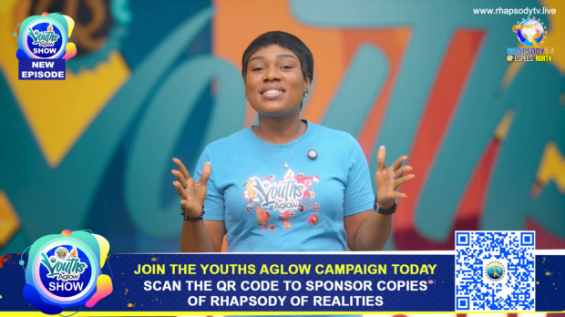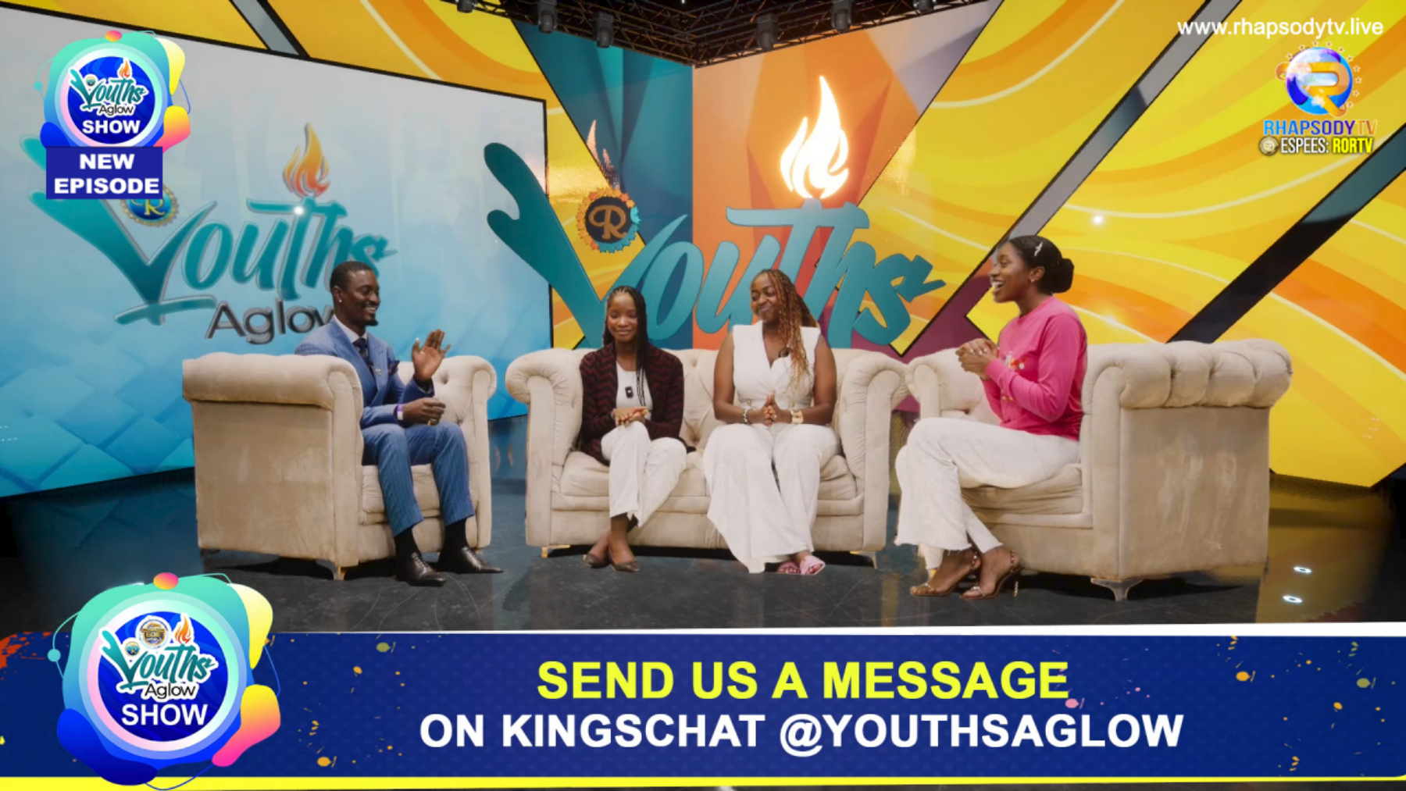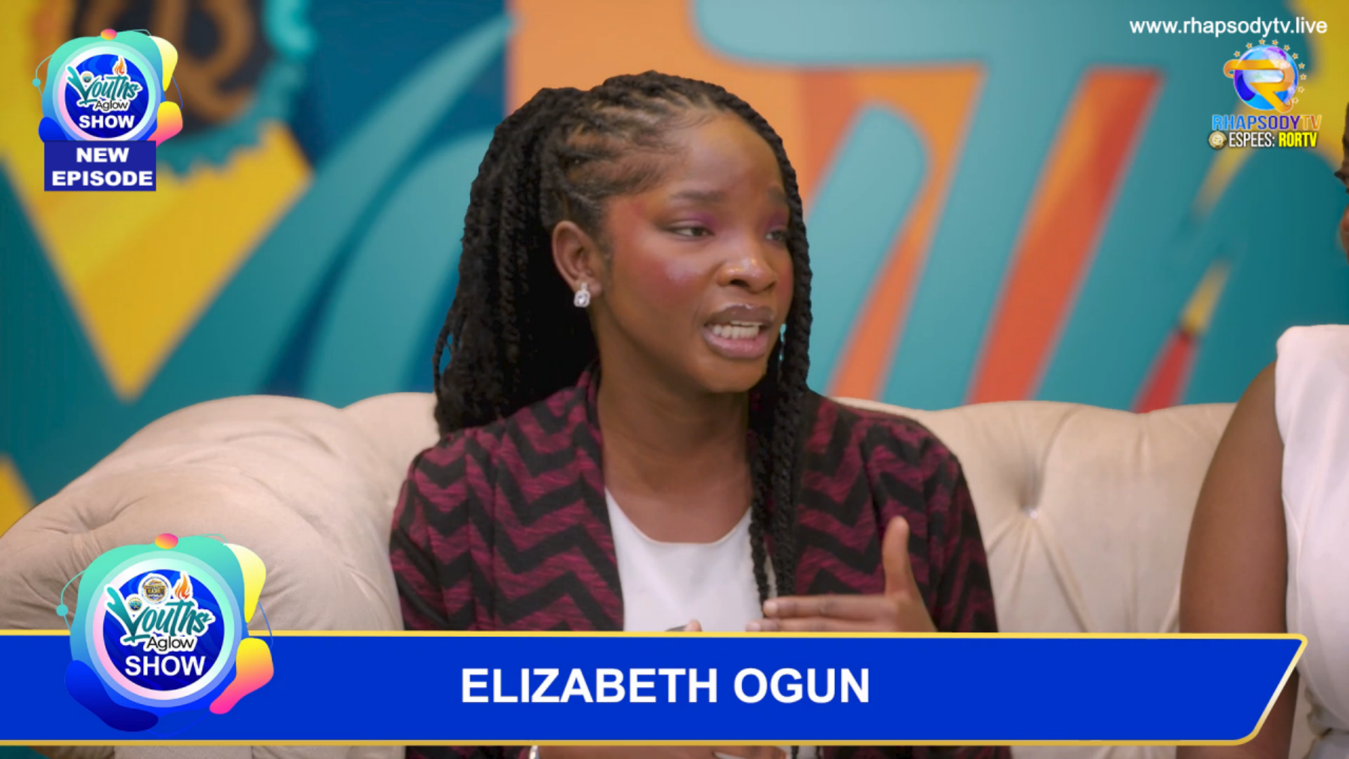
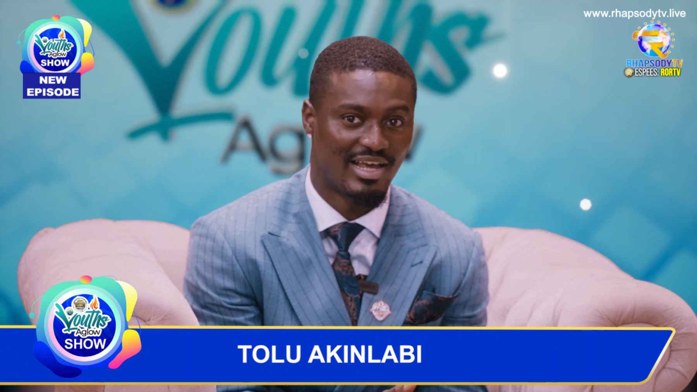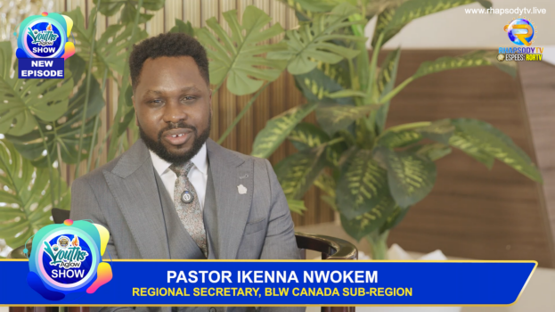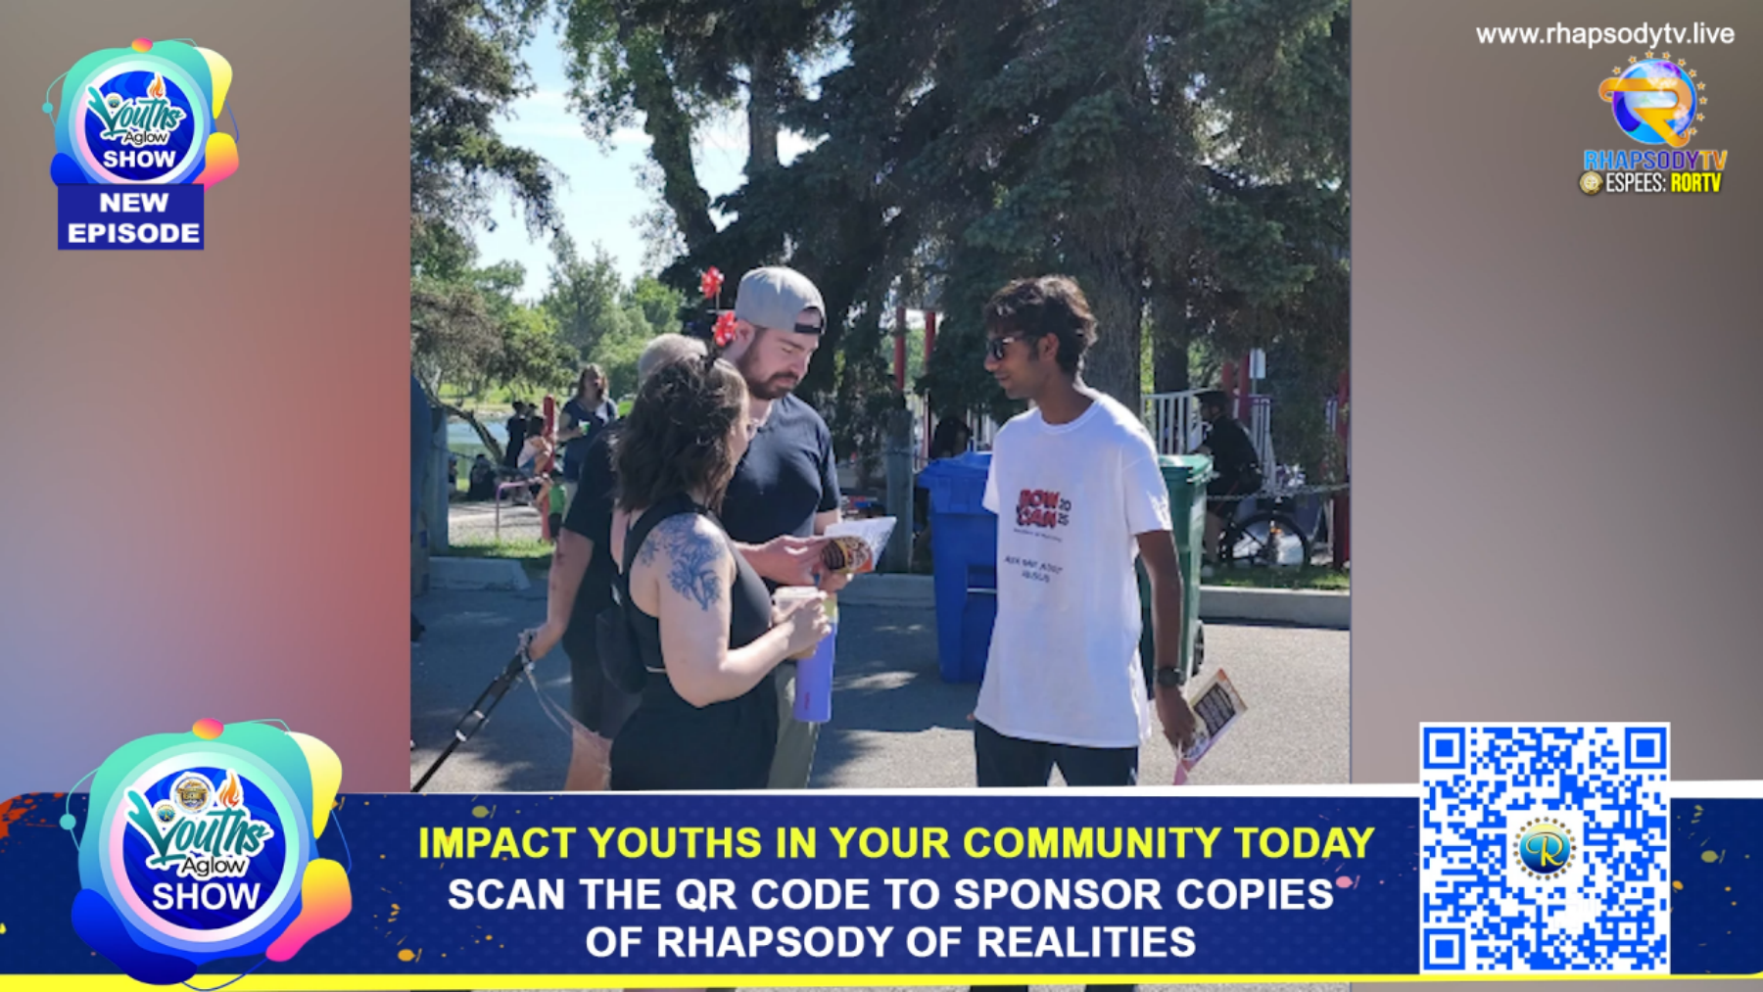

LINKS TO THE VIDEO PREODUCED THIS WEEK AS REQUESTED:
- Youths Aglow Stakeholders Meeting, Director Segment
https://d1ent1.loveworldcloud.com/~rorm/YOUTHS%20AGLOW%202025/DIRECTORS%20SEGMENT%20JULY%2028.mp4
- Youths Aglow Top Sponsoring
https://d1ent1.loveworldcloud.com/~rorm/YOUTHS%20AGLOW%202025/top%20sponsoring%20.mp4
- Youths Aglow Champions League
https://d1ent1.loveworldcloud.com/~rorm/YOUTHS%20AGLOW%202025/CHAMPIONS%20LEAGUE%20EP20.mp4
- Spotlight Moment
https://d1ent1.loveworldcloud.com/~rorm/YOUTHS%20AGLOW%202025/Spotlight%20Ep22.mp4
- Youths Aglow Pastors Segment
https://d1ent1.loveworldcloud.com/~rorm/YOUTHS%20AGLOW%202025/pastor%20ep21.mp4
- Youths Aglow Angel on Campus
https://d1ent1.loveworldcloud.com/~rorm/YOUTHS%20AGLOW%202025/Angel%20On%20Campus.mp4
- Youths Aglow testimony
https://d1ent1.loveworldcloud.com/~rorm/YOUTHS%20AGLOW%202025/Testimony%20Ep22.mp4
- Pastor Chike Ume Segment
https://d1ent1.loveworldcloud.com/~rorm/YOUTHS%20AGLOW%202025/Pastor%20Chike%20Ume%20Segment.mp4
- CEO Segment, Rhapsody End-time Crusade Vanuatu
https://d1ent1.loveworldcloud.com/~rorm/YOUTHS%20AGLOW%20END%20TIME%20CRUSADES/CEO%20SEGMENT.mp4
- Rhapsody End-time Crusade Preparation Video
https://d1ent1.loveworldcloud.com/~rorm/YOUTHS%20AGLOW%20END%20TIME%20CRUSADES/MAHEBOURG,%20MAURITIUS%20.mp4

SECTION A: PERSONAL DETAILS
NAME OF STAFF | CELESTINA NNEOMA IROAJA
NAME OF UNIT: | GPD REGION 5
REPORTING PERIOD: | August Week 1

SECTION B: REPORT
SN | KEY RESULT AREA | KEY PERFORMANCE INDICATOR |  | ACHIEVEMENT FOR THE REPORTING PERIOD | PERFORMANCE MGT SCORE
KRA 1: | TO SET UP ANGEL MARKET PLACE STAND AT EVERY PROGRAMME & STAKE HOLDERS MEETING WITH THE DIRECTOR | - SET UP AM OF EVERY THURSDAY FOR STAKEHOLDERS MEETING MAKING15 JACKETS AVAILABLE FOR PASTORS GOING ON SET TO BUY |  | - SET UP ANGEL MARKET PLACE STAND AND MADE 15 JACKETS AVAILABLE FOR THE PASTORS GOING ON SET TO BUY  - SOLD 4 JACKETS 70 Espees | 40%
KRA 2: | TO SEND OUT COMMUNICATIONS AND CALL 16 RZMS TO ATTEND RPM MEETING AND PREPARE AND SUBMIT ATTENDANCE ALSO ENGAGE 16 RZMS TO PROMPT ZONAL/GROUP PASTORS TO ATTEND STAKEHOLDERS MEETING, PREPARE AND POST ATTENDANCE | - SEND COMMUNICATION TO 16 RZMs EVERY TUESDAY PROMPTING THEM TO ATTEND RPM MEETING AND POST ATTENDANCE EVERY 15 MINUTES  - SEND COMMUNICATION TO 16 RZMS TO PROMPT ZONAL PASTORS TO ATTEND STAKEHOLDER’S MEETINGS EVERY THURSDAY |  | - Sent out Communication to all 16 RZMs and Reps to attend the RPM meeting and 35.7% attendance was achieved  - Sent out Communication to all 16 RZMs to prompt their Zonal Pastors to attend Stakeholders meeting with the Esteemed Director 75.0% attendance was achieved | 51%
KRA 3: | TO PREPARE REGION 5 MONTHLY ACHIEVEMENT REPORTS  TO ENGAGE RZMs TO SEND IN THEIR GROUP PASTORS PICTURES FOR GROUP PASTOR SCORE CARD  TO ENGAGED RZMs TO SEND AND CONFIRM THEIR DATES FOR WONDER CONFERENCE | - PREPARE AND SUBMIT REGION 5 MONTHLY ACHIEVEMENT REPORT  - PREPARE REGION 5 WEEKLY REPORT  - ENGAGED RZMs TO SEND IN PICTURES OF GROUP PASTORS PICTURES FOR GROUP PASTORS SCORECARD  - ENGAGED RZMs TO SEND IN UPDATED GROUP PASTORS DATA BASE  - ENGAGED 32 GROUP PASTORS TO ACKNOWLEDGE 17 STEPS E-CARD DOCUMENT SENT TO THEIR KC HANDLE FOR THE DIRECTORS ATTENTION |  | - STARTED WORKING ON JULY ACHIEVEMENT REPORT  - PREPARE REGION 5 WEEKLY REPORT AND SENT TO MY SUPERVISOR  - ENGAGED RZMs AND GOT PICTURES FOR THE GROUP PASTORS SCORECARD  - ENGAGED RZMs TO SEND IN THEIR TIME AND DATES FOR WONDER CONFERENCE IN THEIR ZONES AND TO SEND THEIR UPDATED DATA BASE  - ENGAGED 54 GROUP PASTORS TO ACKNOWLEDGE THE 17 STEPS E-CARD SENT TO THEM ON KC FOR THE ATTENTION OF THE DIRECTOR.  - ENGAGED 72 GROUP DIRECTLY TO ATTEND THE COMBINED STAKEHOLDERS MEETING ON THURSDAY 78.3% ATTENDANCE WAS ACHIEVED | 40%
 |  |  | TOTAL SCORE |  | 33%

SECTION C: FEEDBACK
COMMENT FROM PERFORMANCE MGT TEAM | COMMENT FROM THE HOP | DATE
Theres a lot more that you can do especially in the area of timeous reporting, engaging stakeholders for meetings and your sales.
DO NOT Report using ALL CAPs

SECTION A: PERSONAL DETAILS
NAME OF STAFF | NWOSU VERNON IFECHUKWUDE
NAME OF UNIT: | GPD MEDIA
REPORTING PERIOD: | 26TH TO 1ST AUGUST 2025

SECTION B: REPORT
SN | KEY RESULT AREA | KEY PERFORMANCE INDICATOR |  | ACHIEVEMENT FOR THE REPORTING PERIOD | PERFORMANCE MGT SCORE
KRA 1: | produce the weekly short videos excerpts from zonal pastors’ stakeholders meetings with the director. | To ensure excepts are produced from the directors meeting for group pastors and cell leaders meetings |  | - I produced an excerpt titled “It's a wonder season do what needs to be done for the Regionalised Meeting  - I produced an excerpt titled “22 Days to August 22 Here's what we Have to do  - I produced an excerpt titled “20 Days to August 22 Here's what we Have to do.  These excerpts further communicate the inspirations of the spirit by the esteemed director aimed at inspiring pastors to take action. these video are always readily available and sent to the studio for play-out, 15 minutes before the start of the programme.
KRA 2: | Creating new video concepts to project our work with Rhapsody in all Reachout world sub campaigns | - To ensure videos aimed at projecting further our work in the Reachout world sub-campaigns are produced for onward deployment |  | I produced the following videos:  - I produced the 30 days to your next 1 million copies day 26 July edition  - I produced the 30 days to your next 1 million copies day 27 July edition  - I produced the 30 days to your next 1 million copies day 28 July edition  - I produced the 30 days to your next 1 million copies day 29 July edition  - I produced the 30 days to your next 1 million copies day 30 July edition  - I produced the 30 days to your next 1 million copies day 31 July edition  - I produced the 30 days to your next 1 million copies day 1 August edition  - I Produced a video for the RECCORDS Sponsoring Zones in the Rhapsody End-time Crusade Live show.  - Recorded and produced 2 Celebration message Videos from HOP GOSS and HOP GPD for esteemed Pastor Amaechi Udeaku and Pastor Ewaen Edun on the occasion of their birthday  The timeline is a day before deployment of the the next day video and it was done and submitted.
KRA 3: | Montage and Promo production | - To ensure these videos help communicate the programme currently running or about to take place for active participation by all. |  | - I produced CELVZ Wonder Conference Promo external link.
KRA 4: | Produce short training videos for mobilization. | - To ensure these training videos encourage and inspire the zones, groups and church networks to sponsor rhapsody and get on the various programme and projects of the department. |  | - Preparing for the Night of A Thousand Crusades  - Taking Ownership of the 17 steps deploy all strategies
KRA 5: | Produce the montages and individual champions videos for the various categories in the weekly 1m champions league | - To ensure a montage is created and individual champions video for various categories is readily available for announcement before the zonal pastors meeting begins |  | - I produced 22 individual video of the champions league awards  - I produced highlight video of the champions league awards for the Group Pastors meeting  This video was produced and submitted 15 minutes before the programme as expected.
KRA 6: | Collaborate with the strategic media team to produce RPM meeting | - To ensure the media team receives all the videos needed for a hitch free production in the studio and control room |  | - Led by Pastor Tosin, I worked to ensure videos, motion and still graphics needed are properly scheduled, proof read, as well as manning the production laptops.
KRA 7: | Collaborate with the strategic media team to produce Rhapsody End Time Live Show | - To ensure the media team receives all the videos needed for a hitch free production in the studio and control room |  | - Led by Pastor Tosin, I worked to ensure videos, motion and still graphics needed are properly scheduled, proof read, as well as manning the production laptops.
KRA 8: | Collaborate with the strategic media team to produce the Zonal Pastors stakeholders strategy meeting | - To ensure the media team receives all the videos needed for a hitch free production in the studio and control room |  | - Led by Pastor Tosin, I worked to ensure videos, motion and still graphics needed are properly scheduled, proof read, as well as manning the production laptops.
KRA 9: | Collaborate with the strategic media team to produce the Group and church pastors stakeholders strategy meeting | - To ensure the media team receives all the videos needed for a hitch free production in the studio and control room |  | - Led by Pastor Tosin, I worked to ensure videos, motion and still graphics needed are properly scheduled, proof read, as well as manning the production laptops.
KRA 10: | Collaborated with the strategic media team to produce the rhapsody stakeholders strategy meeting for America and Canada regions. | - To ensure the media team receives all the videos needed for a hitch free production in the studio and control room |  | - Led by pastor Tosin, I worked to ensure videos, and any other media request needed are available for the production.
KRA 11: | Collaborated with the strategic media team to produce the Rhapsody Strategic Training for Cell Leaders with the Esteemed Director. | - To ensure the media team receives all the videos needed for a hitch free production in the studio and control room |  | - Led by Pastor Tosin, I worked to ensure videos, motion and still graphics needed are properly scheduled, proof read, as well as manning the production laptops.
 |  |  | TOTAL SCORE |  | 92%

SECTION C: FEEDBACK
COMMENT FROM PERFORMANCE MGT TEAM | COMMENT FROM THE HOP | DATE
You could also attach links to video, pictures etc to buttress your report and always proof read your report as it contains lots of errors and typo.

GDP UNIT’S WEEKLY REPORT
JULY WEEK 4, (July 28th to July 31st)

UNIT NAME: GPD TECHNICAL AND INNOVATIONS UNIT
DATE SUBMITTED: 1-08-2025
GOALS VS ACHIEVEMENTS
GOALS | SUMMARY OF ACHIEVEMENTS
Weekly Stakeholder Meetings (RPM Meeting Attendance) | Attendance submission at 25 minutes intervals, enabling the regions to contacts their stakeholders promptly. | I've noticed that our stakeholder contacts times have been longer than expected over the past few weeks. The 25-minute interval attendance submissions were intended to help regions reach out to stakeholders promptly, but we're not seeing the results we need. Can we discuss on the cause?
Night of a thousand Crusades Registration Dashboard | - Created a registration dashboard for real-time monitoring of the registrations with statistics for the upcoming event. Visit https://rhapsodycrusades.org/notc/public-dashboard (public dashboard)
Rhapsody End-Time Crusades Website | - Updated the registration to capture multiple countries and cities, as well as documenting the number of crusades, as well as other requested updates.
ROR Wiki | - A first draft of this (demo) has been presented. Visit https://rorwiki.org
 | - total | 90%

SECTION A: PERSONAL DETAILS
NAME OF STAFF | Sis Nita Ukeje
NAME OF UNIT: | GPD Region 4
REPORTING PERIOD: | July week 4

SECTION B: REPORT
SN | KEY RESULT AREA | KEY PERFORMANCE INDICATOR | ACHIEVEMENT FOR THE REPORTING PERIOD | PERFORMANCE MGT SCORE
KRA 1: | Regional meetings | - Prepare meeting schedule/agenda  - Prepare and send prayer points & Faith proclamations  - Produced attendance scorecard, minutes and action points from the meeting  - Send out reminders and engage and mobilize for maximum attendance  - Plan for special training and segments in the regional meeting  - Mobilize for maximum attendance in the RPM and Zonal Pastors meeting | - Prepared regional meeting schedule for Monday, Tuesday, Wednesday, Thursday and Friday (meeting starts by 6:45am)  - Sent out the schedule for the 5 days on Sunday on the regional group  - Sent out reminders on the groups every day by 6:15 am, another notification of ongoing meeting by 7:00am  - Engaged managers through calls and chats and achieved an average of 80% attendance for the week in the regional meeting  - Prepared attendance scorecard and highlights for all meeting days (Monday, Tuesday, Wednesday, Thursday and Friday) and deployed on the regional group page  - Drafted out 5 Invitation letters to campaign personnels from Teevolution, HOD Rhapsody Digital Products, HOU Rhapsody Global Call center, ABTM and to the HOD Rhapsody Prayer Network to handle trainings in the regional meeting this week (Monday, Tuesday, Wednesday, Thursday and Friday)  - Deployed publicity ecards and notifications for each of the trainings to mobilize attendance for these training on the regional group a day before  - Sent out reminders and the meeting notification for the RPM and Zonal pastors stakeholders’ meetings on the regional page, also engaged managers through calls  - Achieved 65% attendance of stakeholders in the RPM | For the stakeholders meeting. What could be the cause of the low attendance?  was it timing, communication method, or stakeholder priorities?  This will help for future 100% attendance achievement
KRA 2 | Teevolution campaign communication and superuser and Region 4 campaign liaison B | - Administratively drive for sponsorship and the deliverables of the teevolution campaigns  - Manage the teevolution campaign communication and Super user accounts  - Testimonies drive (200 testimonies every week) | - Prepared Teevolution posting schedule for the campaign day (Friday) and sent out to RCN to facilitate posting on Rhapsody superusers  - Prepared copy lines for contents and made post on the TeeVo Super user on the campaign day (Friday)  - Drove for publicity of post by liking and resharing on groups and official handles for each post  - Engaged managers in the region lastest on Thursday to resolving all pending receipts needed to celebrate Teevolution top sponsoring groups and zones on Friday  - Engaged managers on testimonies with scorecards, chats and calls, we had 5 testimonies from the region this week | Does the deliverables not have a timeline?  5 testimonies as against 200. What could be the reason for the low turnout, did you find out?
KRA 3: | Other assignments | - Partners and stakeholders’ celebration  - Strategic engagement trip | - Sent out messages and reminders to managers of zones with stakeholders’ birthday this past week, requesting pictures and details of celebrants  - Sent pictures and details to the graphics personnel and the Gpd region 4 partners celebration group for the attention of the regional manager as well  - QCed all celebratory ecards  - Deployed ecards on the regional handle and shared on the regional pages  - Prepared budget for three trips as requested by the regional meeting  - Followed up for the funding, ticket booking and partners sourvenirs for the trip  - Accompanied the regional manager for strategic trip to Ministry Calabar for their Rhapsody wonder conference  - Ensured to get all necessary arrangements needed by the regional manager in preparing for every session handled during the conference  - Captured moment in pictures for reports  - Prepared report of the trip and the outcome
 |  |  | - Total | 50%

SECTION C: FEEDBACK
COMMENT FROM PERFORMANCE MGT TEAM | COMMENT FROM THE HOP | DATE
Refer to the root cause of your low attendance and improve on it.

SECTION A: PERSONAL DETAILS
NAME OF STAFF | SIS GIFT
NAME OF UNIT: | GPD OPERATIONS
REPORTING PERIOD: | July 28th - 2nd August

SECTION B: REPORT
SN | KEY RESULT AREA | KEY PERFORMANCE INDICATOR |  |  | ACHIEVEMENT FOR THE REPORTING PERIOD | PERFORMANCE MGT SCORE
KRA 1: | Meeting  Operations | Meeting Operations |  |  | This week, we successfully coordinated four strategic stakeholder meetings, each aligned with the 25 Weeks of Rhapsody Extravaganza, to drive the 4 million copies per Group mandate.  ✅ Meetings Executed:  • Rhapsody Partnership Managers Meeting  • Group & Church Pastors Stakeholders Meeting (with GPIO)  • Zonal Pastors Stakeholders Meeting  • Rhapsody Strategy Training for Cell Leaders  ✅ Strategic Communication:  - Designed and deployed targeted e-cards, email alerts, and KC messages to ensure full stakeholder participation.  - Created a seamless meeting experience that inspired action and sharpened focus across all Stakeholders levels.  ✅ Results:  - Delivered clear direction and renewed momentum toward the 4 million copy goal.  - Strengthened collaboration across Zones, Groups, and Cell Leaders for synchronized execution.  We are on course and fully committed to exceeding our targets in this Rhapsody Extravaganza Season — with visible impact and undeniable results!
KRA 2: | Rhapsody  Partnership  Managers  Meeting | Rhapsody Partnership Managers Meeting |  |  | This week, we successfully coordinated and executed the Rhapsody Partnership Managers Meeting with the Highly Esteemed HOP, ensuring seamless delivery and strategic alignment with our 4 million copy goal.  ✅ Key Actions & Impact:  • Proactively engaged all relevant stakeholders during the preparation phase.  • Designed and deployed fresh, branded e-cards and communication materials to drive awareness and participation.  • Mobilized and coordinated RZMs selected to share, ensuring full readiness.  • Sent timely reminders and preparatory updates for maximum attendance.  • Updated the streaming platform with current e-cards and cleared backend systems to ensure glitch-free transmission.  • Documented and compiled meeting minutes and action points for immediate follow-up and future reference.  These efforts directly contributed to the successful execution of the meeting and reinforced stakeholder momentum toward our sponsorship targets.
KRA 3: | Zonal Pastors Meeting | Zonal Pastors Meeting |  |  | This week, I successfully coordinated the Zonal Pastors Stakeholders Meeting, hosted by the EWCA Region, ensuring a flawless execution and impactful experience for all participants.  ✅ Key Achievements:  • Drafted and dispatched official invitations to featured Zonal Pastors across six zones, ensuring early confirmation and readiness.  • Sent formal letters to Pastors in the next host region for seamless handover and continuity.  • Engaged all relevant stakeholders, aligning them with the vision and expectations for the meeting.  • Designed and deployed fresh e-cards, communication assets, and prayer points for spiritual alignment and participation.  • Updated the streaming site with all required visuals and cleared backend systems for a glitch-free broadcast.  • Personally coordinated with RZMs to collate impact reports and images for the Zonal Pastors’ presentations—ensuring the control room had real-time visuals to support each talk.  • Arranged and delivered the Zonal Pastors’ “Thank You Box” from the Esteemed Director as a thoughtful expression of appreciation.  Outcome:  An excellently coordinated stakeholders meeting with strong participation, impactful delivery, and positive feedback—all contributing to the continued drive toward our 4 million Rhapsody copies goal.
 | Cell Leaders Engagement | ▪ Preparations and Plans for the meetings |  |  | This week, I successfully coordinated the Cell Leaders Stakeholders Meeting, aligning it with our 25 Weeks of Rhapsody Extravaganza focus: Every Cell a Rhapsody Wonder Sponsorship.  ✅ Key Achievements:  • Engaged and guided 4 Cell Leaders, ensuring 2–4 shared impactful sponsorship testimonies live during the session.  • Sent tailored briefing scripts to speakers and collected their pictures and reports to enrich their presentations.  • Developed the prayer points for the upcoming meeting, fostering spiritual preparation.  • Crafted and dispatched over 3,000 SMS reminders to Cell Leaders across regions to drive participation.  • Drafted weekly communication content centered on the current focus and ensured alignment in all stakeholder messages.  • Liaised with the Highly Esteemed Pastor Joy and Pastor Christine, sending links and agreed dress code for visual excellence and unity.  • Ensured the final meeting script reached the Highly Esteemed Pastor Joy, following up until confirmation.  • Managed the live meeting operations as both floor manager and coordinator, ensuring seamless delivery.  • Compiled and submitted the post-meeting report and attendance log for proper documentation and follow-up.  Outcome:  A highly engaging Cell Leaders Meeting that reinforced sponsorship culture at the cell level and fueled momentum toward our global 4 million copy goal.  .
 | GPD Staffs Welfare | ▪ Birthday Celebration of Staff Members |  |  | • Celebrated Esteemed Pastor Kemi with a beautifully designed e-card, thoughtful Gift and a heartwarming tribute from the department, recognizing her dedication and outstanding contributions to the GPD Department.
 | Others |  | ▪ | ROR Communications  YOUTH Aglow Stakeholders Meeting | Sent out Crusades documents through the KC  Sent Prayer Schedule on the Road To Night of a Thousand Night to all Groups  Engagement all Lagos Rzms to get their Youth Pastor Feature for the weekly stakeholders meeting.
 |  |  |  |  | TOTAL SCORE | 90%

SECTION C: FEEDBACK
COMMENT FROM PERFORMANCE MGT TEAM | COMMENT FROM THE HOP | DATE

SECTION A: PERSONAL DETAILS
NAME OF STAFF | Elisha Shedrack
NAME OF UNIT: | GPD communications
REPORTING PERIOD: | Week 1 (28th July – 3rd August)

SECTION B: REPORT
SN | KEY RESULT AREA |  | KEY PERFORMANCE INDICATOR | ACHIEVEMENT FOR THE REPORTING PERIOD | PERFORMANCE MGT SCORE
KRA 1: | To produce:  - Rhapsody partnership managers document |  | To produce:  - To produce 4 document per month | 1 RPM meeting documents was produced
KRA 1: | - Action points from the “30 days to your next 1 million copies” video content which would be used to produce necessary scripts by the Rhapsody communication Unit |  | - To produce (30 action points for each month) from the “30 days to your next 1 million copies” video content | 7 actions points were produced for the month which was used to produce necessary scripts by the Rhapsody communication Unit
KRA 1: | - Monday morning blessing card |  | - To produce 4 ecards per month | 1 Monday morning blessing cards was produced
KRA 1: | - Chat scripts to accompany the GPD meeting publicity cards to the Rhapsody support group, AND Chat scripts to accompany each post on the SuperUser: (ROR, ABTM, YOUTHS AGLOW, RHAPSODY PARTERS) superusers |  | - Numbers based on the amount of meeting | Produced 60 communications scripts to accompany the GPD meeting publicity cards and accompany each post on the SuperUser: (ROR, RTV, ABTM, YOUTHS AGLOW, RHAPSODY PARTERS) superusers
KRA 1: | - GPD Monday meeting post report |  | - To produce 4 GPD Monday meeting post report per month | Produced 1 GPD Monday meeting post report
KRA 1: | - GPD Friday HOD/HOU meeting post report |  | - To produce 4 GPD Friday HOD/HOU meeting post report | Produced 1 GPD Friday HOD/HOU meeting post report
KRA 2: | To Deploy: |  | To Deploy:
 | 30 days to your next 1 million copies video and script content |  | 30 contents to be deployed on the “30 days to your next 1 million copies” | 7 video and script contents were deployed on the “30 days to your next 1 million copies” this month
 | - Post report of RPM, zonal pastor, group pastor and cell leaders meeting document |  | - 4 post reports to be deployed each week for each meeting. | - The ZP post report was deployed for the week  - The GP post report was deployed for the week  - The Regionalized meeting post report was deployed for the week  - The combined pastors meeting post report was deployed
 | - The Rhapsody Daily campaign |  | - Total posts deployed is depended on the total contents received (there is no limit to the content) | Received and deployed a total of over 98 communications content for Penetrating with languages, say yes to kids, No one left behind, a billion testimonies and more, wonder challenge, TeeVolution, youths aglow, top sponsoring zones Monday blessing card Was deployed
 | - Live shows like: This morning show with Rhapsody of Realities, Global Day of Prayer, communion service, your LoveWorld specials, healing streams live healing service, a billion testimonies and more, Reach out world/ show |  | - charged with the responsibility of publicizing these shows while they are live for that time duration to drive engagement. | Received and deployed a total of 60 contents as regards live shows
 | - RZM monthly scorecard |  | - Total scorecard deployed is depended on the total scorecard received. | none was received and deployed
 | - Wednesday service document |  | - To deploy 4 service document per month if received | 1 Wednesday service outlines were received and deployed
 | - Sunday service document |  | - To deploy 4 service documents per month if received | 1 Sunday service outlines were received and deployed
 | - Partners celebratory post |  | - Total posts deployed is depended on the total partners celebrated. | Received and Deployed 14 Appreciation posts including birthdays and anniversaries according to the database.
KRA 3: | COLLABORATIONS |  | - MEDIA DEPARTMENT | - collaborated with the media department to ensure that the live show “THIS MORNING WITH RHAPSODY”, A BILLION TESTIMONIES AND MORE, YOUTHS AGLOW TV SHOW, ETC was publicized to ensure engagements with over 65 publicity posts. And over 700 views, over 27 reshares and over 1002 likes  - collaborated with the Rhapsody communication unit of GOSS to produce and deploy over 7 video and script contents to 88 Rhapsody support groups to drive the completion of 4 million copies as a group and 100 million copies as a zone
 | INNOVATION |  |  | - Successfully created a method and template of deploying communication to 88 Rhapsody support groups within 5 mins (it usually took 40 mins to deploy prior to now) | What was it? You did not clearly present what it was
 |  | TOTAL SCORE |  |  | 70%

SECTION C: FEEDBACK
COMMENT FROM PERFORMANCE MGT TEAM | COMMENT FROM THE HOP | DATE
You really need to work on, Your engagement, viewship and impact.

SECTION A: PERSONAL DETAILS
NAME OF STAFF | FAITH-IBRAHIM OFUNNE
NAME OF UNIT: | GPD REGION 4
REPORTING PERIOD: | JULY WEEK 4

SECTION B: REPORT
SN | KEY RESULT AREA |  | KEY PERFORMANCE INDICATOR | ACHIEVEMENT FOR THE REPORTING PERIOD | PERFORMANCE MGT SCORE
KRA 1: | Administration |  | Income | - Drove for income alongside my HOD through my administrative responsibilities in the Region. This week, we achieved  - 486 650 copies sponsored from a total of 6 zones  - Additionally, we recorded a total of 12 Wonders in the Region, placing my Region in the number one position for the highest number of Wonders this week.
 |  |  | ENGAGEMENT | STAKEHOLDERS ONLINE ENGAGEMENT WITH THE GROUPS AND THE REGIONAL MANAGER  - I drafted an engagement schedule with 32 Groups and engaged the RZMs of these Groups for collaboration, ensuring we achieve the required audience numbers for a shift in sponsorship.
 | Rhapsody Wonder Crusade |  |  | I engaged the RZMs who were yet to confirm their Crusade dates or ministers, as instructed by my Regional Manager. I gathered the necessary updates, updated the document accordingly, and sent it to my HOD.
 | To coordinate/moderate the Regional meeting with the Regional managers daily |  |  | - I moderated/coordinated 4 daily regional prayer and review meetings with the Regional Manager and RPMs daily. These meetings were held from Monday to Friday from 6:45AM to 8:00AM.  - I placed a total of 11 calls to get the attention to login  22 out of 24 RZMs from 20 Zones connected to these meetings
 | Call center |  |  | - Following up on the recent call center training, I engaged all the RZMs to confirm the number of call centers in their Zones and Groups, as well as their effectiveness. So far, I have confirmed over 250 call centers across the Groups and Churches.
 | Zonal statements |  |  | ZONAL STATEMENT:  - I prepared the Zonal Statement for the 20 Zones and deployed to the RZMs  - I forther engaged them to confirm they received it
 | REGIONAL REPORTS |  |  | - I updated the Regional monthly report with additional achievement and activities and sent to the Esteemed Pastor Kumbi for upload  - I prepared the CEO’s chat report and sent to my Regional manager.  All these reports captured our Regional engagement, achievements, strategic meetings/prayer meetings held this week and administrative work done.
 | PRINT PRODUCTION |  |  | - I placed calls to the 19 RZMs to confirm whether they had received their copies and the quantity received. I was able to speak with 17 RZMs and I confirmed that 16 Zones have received their August copies, totaling 311,700 copies  - I sent messages to this regard and several chats to this done faster  - Drove for print payment for August copies requested by the Zones | There was no outcome of what they received as against what they ordered? Nothing is said about those who did not receive
 |  |  | OTHER ADMINISTRATIVE WORK DONE | - Drove for sponsorships of Wonder through the RZMs and Group manager  - Engaged and gather information for all reports  - I posted the Wonder details for avatar production and publicized the cards on all our platforms.  - Gathered information for the regional reports and all information for the CEO’s chat report  - Worked with Sister Nita to engage Zones on Groups Status report
 |  | TOTAL SCORE |  |  | 80%

SECTION C: FEEDBACK
COMMENT FROM PERFORMANCE MGT TEAM | COMMENT FROM THE HOP | DATE
Most of your administrative roles are a 100% deliverables, nothing Is ever said about those who did not join meeting, the zones who did not get Rhapsodies etc.

SECTION A: PERSONAL DETAILS
NAME OF STAFF | JENNIFER ODOGU
NAME OF UNIT: | GPD REGION 3
REPORTING PERIOD: | 2ND AUGUST

SECTION B: REPORT
SN | KEY RESULT AREA | KEY PERFORMANCE INDICATOR |  | ACHIEVEMENT FOR THE REPORTING PERIOD | PERFORMANCE MGT SCORE
KRA 1: | ADMINISTRATION & OPERATION MANAGER | INCOME |  | - Drove income through my administrative assignment across the entire structure of the region. This week, we achieved  5,598,606 copies paid for from total of 14 zones | Impressive outcome!
KRA 2: |  | - STATEMENT OF ACCOUNT & DAILY INCOME REPORT |  | STATEMENTS OF ACCOUNT  What we did:  - Prepared and deployed 19 statement scorecards for zonal Pastors for the month of July.  - The scorecard showed a quick view of total sponsorship done so far in 2025.  - Sponsorship done in July.  - Total sponsorship done across all campaigns.  - Total wonder done by zone.  - Number of copies ordered and amount paid and outstanding with % achieved so far.  - Overall total payment paid for printed copies.  This helped the zonal Pastors see how much they sponsored in July and areas that need immediate attention  - I scripted a Welcome to the New Week message, and deployed with the statement to the Pastors  - I successfully deployed this to all 20 zonal Pastors in the region Via KC  Key results: | What was the outcome of these deployed statements. No feedback received?
KRA 3: |  | - PRINT & PRODUCTION |  | As at 1st of August all the zones have placed their order on the ordering portals | And none has received their August order?
 |  | - ENGAGEMENT |  | - Engaged 20 Zonal pastors on KC with the statement of account which generated income  RZMS Engagement:  - Dispatch 32 notification for our 4.30am regional prayer meeting Monday 28th – 1st of August  - Sent Wednesday service outline to 227 RZMs  - Engaged the RZMs for the Groups updated breakdown for the champions league – collated records for the esteemed HOD  - Made a total of 80 calls to the RZMs this week via calls (prayer, regional and central meetings)  - Mobilized for 100% attendance but achieved 90%  - Mobilized for the 4:30 am prayer meeting with a total of 102 notifications  - Mobilized attendance for regional meeting held at 2pm–report  - Received inbound calls to resolve and solve pending tasks with RZMs information on e.g Night of a thousand crusade  Made a total of 180 calls and 289 KC | Outline to 227 RZMs?
 |  | - MEETINGS |  | - Organized the regional meeting which held on 29th of July  - Prepared agenda and talking script  - Drove attendance for meeting  - Prepared minute of meeting and deployed on the RZMs & RGMs platforms & to 27 RZMs in the region  - Regional prayer  - Organized the prayer meeting every morning by 4.30am and 4 held this week Monday -Thursday then we joined central on Friday  - Sent notification and prayer point to the region’s platform  - Rpm meeting with HOP  - Called the RZMs to connect to the meeting and achieved a total of 85%  - Drove attendance through notification @10pm & 4.25am everyday including prayer with HOP  Zonal Pastor meeting  - 55% attendance of zonal pastor (that is because the ZPs where out stationed according to the RZMs) | the stakeholders meeting low attendance turnout has been a concern to the Esteemed Director. What are you doing to achieve a 100% attendance?  Could it be timing, communication method or stakeholders priorities?
 |  | - COMMUNICATION |  | This week, we dispatched a total of 1,258 communications to all our esteemed stakeholders  - Welcome to the Zonal Pastors this week.  - Deployed 19 statement scorecards to Zonal Pastors  - Deployed we are live link to RZMs for meeting with HOP, and director meeting  - Dispatched regional review meeting notification before & during the meeting with screenshots  - Sunday and Wednesday service outlines, deployed notifications on regional, central and all stakeholder meetings, prayer meetings, on testimonies and on order and print (RZMs)  - Deployed the NOTC zonal schedule and outline to the RZMs for the road to NOTC prayer march  - Deployed all publicity materials and promos for the NOTC
 |  | - REPORT |  | - Chat report to the CEO done & to RM on Thursday
 |  | - ADMINISTRATION |  | SYTK Training with RZMs & Regional Partnership Managers  - Prepared official invitation letter to the SYTK team  - We organized the SYTK campaign training meeting for all RZMs and regional partnership managers, kindly see details & strategies discussed during the training  FACILITATED BY PASTOR FLOURISH – highlight of things discussed seen below  Sponsorship Strategy Levels:  - 1-100 copies: Entry level  - 101-999 copies: Intermediate level  - 1,000-9,999 copies: Advanced level  - 10,000+ copies: Silver league status  - Goal to bring all zones to league level  Outreach Strategies:  - Engage professional schools and industries as sponsors  - Reach children in remote places, villages, inner cities  - Utilize school holiday periods (August) for strategic outreach  - Target children on streets, playgrounds, through parents and neighbours  - Focus on teaching children to read using Rhapsody of Realities  - Commission work across Nigeria, West Africa, Central Africa, and capital cities  Key Action Points  1. First 100 Children Challeng. Timeline: Immediate implementation  2. Children-to-Children Distribution: Method: Children distributing Rhapsody materials to peers  3. Children's Media Engagement: Purpose: Inspire other parents to let their children participate  4. Say Yes to Kids Crusades: Safety: Take small groups (5-10 children) with parental supervision  5. Zone Representatives: Requirement: Each zone to have dedicated children's representatives  Reporting Requirements: Submit regular reports with pictures and documentation, track sponsorship numbers and engagement metrics & Share success stories and testimonials  Timeline: August: Begin Say Yes to Kids crusades and distributions. September: Prepare for back-to-school initiatives Ongoing: Monthly distribution campaigns and media engagement  Next Steps  - Zones to begin immediate implementation of all five action points  - Regular reporting and updates required  - Follow-up meetings to track progress and celebrate achievement
 |  |  | TOTAL SCORE |  | 90%

SECTION C: FEEDBACK
COMMENT FROM PERFORMANCE MGT TEAM | COMMENT FROM THE HOP | DATE
Kindly go through the comments made

PICTORIAL REPORT
Statements prepared and deployed to ZPs
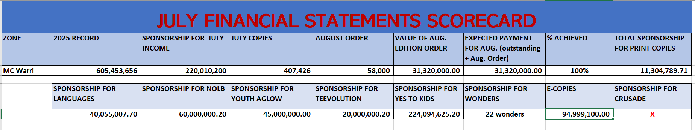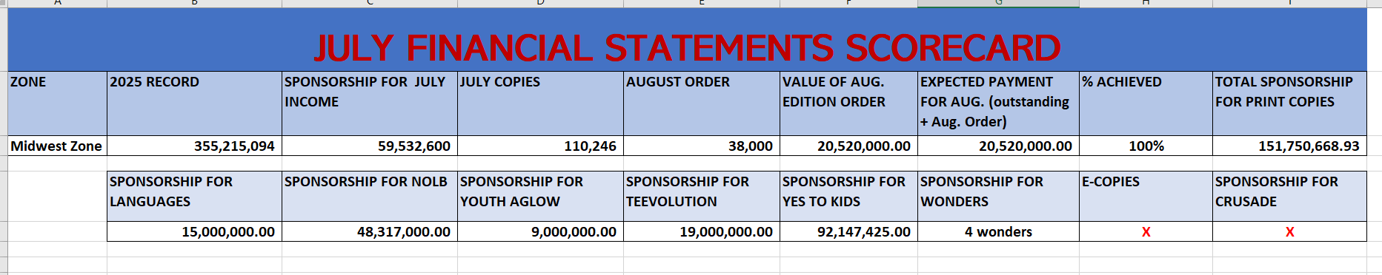
Letters deployed to ZPs
