BROTHER VERNON NWOSU 2025 ACHIEVEMENT LINKS

WEEKLY SHORT VIDEOS EXCERPTS
- https://d1ent1.loveworldcloud.com/~rorm/17-Days-to-Augus-22-Here%20s-wha-we-Have-to-do.mp4
- https://d1ent1.loveworldcloud.com/~rorm/COMPLETENESS-IN-PREPAREDNESS.mp4
- https://d1ent1.loveworldcloud.com/~rorm/WHAT-HAPPENED-AND-WHAT-MORE-CAN-WE-MAKE-HAPPEN.mp4
- https://d1ent1.loveworldcloud.com/~rorm/A-SEASON-OF-UNENDING-HARVESTS.mp4
- https://d1ent1.loveworldcloud.com/~rorm/RHAPATHON-READINESS-AND-MORE.mp4
- https://d1ent1.loveworldcloud.com/~rorm/HARVEST-THE-FRUITS-OF-RHAPATHON-.mp4
- https://d1ent1.loveworldcloud.com/~rorm/TIME-TO-LEAVE-THE-REALM-OF-JOKES.mp4
- https://d1ent1.loveworldcloud.com/~rorm/STRATEGIES-TO-HIT-100-MILLION-COPIES.mp4

TRAINING VIDEOS
- https://d1ent1.loveworldcloud.com/~rorm/Making-Progress-Upward-The-17-Steps-Of-Glory-Moving-By-The-Wonders.mp4
- https://d1ent1.loveworldcloud.com/~rorm/Cellular-Crusades-Training.mp4
- https://d1ent1.loveworldcloud.com/~rorm/Working-Wonders-Through-Your-Zonal-Rhapsody-Wonders-Conference-How-to-Mobilize-the-Brethren-for-4-Million-Copies-Per-Group-.mp4
- https://d1ent1.loveworldcloud.com/~rorm/ONSITE-CRUSADE-PLANNING-TO-EXECUTION.mp4
- https://d1ent1.loveworldcloud.com/~rorm/From-Planning-to-Execution-A-Comprehensive-Night-of-a-Thousand-Crusades-Preparedness.mp4
- https://d1ent1.loveworldcloud.com/~rorm/Top-10-Essentials-to-Organizing-Big-Crusades-Tomorrow.mp4
- https://d1ent1.loveworldcloud.com/~rorm/Top-10-Reports-to-Submit-After-the-Crusades.mp4
- https://d1ent1.loveworldcloud.com/~rorm/Top-10-Resources-Available-on-the-Crusade-Website.mp4
- https://d1ent1.loveworldcloud.com/~rorm/Top-10-Ways-to-Optimize-your-Call-Centre-for-Absolute-Success-In-Achieving-Deep-Penetration-During-Pre-Live-and%20Post%20program.mp4
- https://d1ent1.loveworldcloud.com/~rorm/Pastor-Aloy-session-on-NOTC-Global-Town-Hall-Meeting.mp4
- https://d1ent1.loveworldcloud.com/~rorm/Pastor-Joy-session-on-NOTC-Global-Town-Hall-Meeting.mp4
- https://d1ent1.loveworldcloud.com/~rorm/Pastor-Kay-session-on-NOTC-Global-Town-Hall-Meeting.mp4
- https://d1ent1.loveworldcloud.com/~rorm/Pastor-Dipo-session-on-NOTC-Global-Town-Hall-Meeting.mp4
- https://d1ent1.loveworldcloud.com/~rorm/Pastor-Christine-session-on-NOTC-Global-Town-Hall-Meeting.mp4
- https://d1ent1.loveworldcloud.com/~rorm/Rev-Tom-session-on-NOTC-Global-Town-Hall-Meeting.mp4
- https://d1ent1.loveworldcloud.com/~rorm/H-E-Dirctor-session-on-NOTC-Global-Town-Hall-Meeting.mp4
- https://d1ent1.loveworldcloud.com/~rorm/Rhapsody-Wonders-Conference-Turning-Pledges-to-Giving.mp4

MONTAGE AND PROMO PRODUCTION
- https://d1ent1.loveworldcloud.com/~rorm/CHAMPIONS-LEAGUE-HEROES-EDITION-.mp4
- https://d1ent1.loveworldcloud.com/~rorm/CHAMPIONS-LEAGUE-GROUP-PASTORS-EDITION.mp4
- https://d1ent1.loveworldcloud.com/~rorm/Rhapsody-says-Thank-you-for-25-Years---.mp4
- https://d1ent1.loveworldcloud.com/~rorm/Rhapsody-Wonder-Conference-By-Pastor-Lanre-&-Pastor-Moses-.mp4
- https://d1ent1.loveworldcloud.com/~rorm/WONDER-CONFERENCE-PROMO-CHURCH.mp4
- https://d1ent1.loveworldcloud.com/~rorm/Rhapsody-End-Time-Crusade-Live-Series-live-show-.mp4
- https://d1ent1.loveworldcloud.com/~rorm/Road-to-Night-of-a-Thousand-Crusades-Promo-.mp4
- https://d1ent1.loveworldcloud.com/~rorm/MyStreamspace-promo-.mp4
- https://d1ent1.loveworldcloud.com/~rorm/CELVZ-Wonder-Confernce-Montage-.mp4
- https://d1ent1.loveworldcloud.com/~rorm/MyStreamspace-promo-.mp4
- https://d1ent1.loveworldcloud.com/~rorm/Road-to-Night-of-a-Thousand-Crusades-Promo--.mp4
- https://d1ent1.loveworldcloud.com/~rorm/CHRONICLES-OF-NIGHT-OF-A-THOUSAND-CRUSADES-PROMO-updated.mp4
- https://d1ent1.loveworldcloud.com/~rorm/Pastor-Speaks-on-Rhapathon.mp4
- https://d1ent1.loveworldcloud.com/~rorm/Pastor-speaks-on-Rhapsody-wonder-and-entering-a-phase-of-massive-teaching.mp4
- https://d1ent1.loveworldcloud.com/~rorm/CELEBRATING-ZONAL-PASTORS-THAT-HAVE-DONE-A-WONDER-PROMO-ok--.mp4
- https://d1ent1.loveworldcloud.com/~rorm/Pastor-speaks-on-Rhapsody-wonder-and-entering-a-phase-of-massive-teaching.mp4
- https://d1ent1.loveworldcloud.com/~rorm/Pastor-Speaks-on-Wonders-and-Rhapathon.mp4
- https://d1ent1.loveworldcloud.com/~rorm/PASTOR-SPEAK-ON-100-MILLION-COPIES-ok.mp4
- https://d1ent1.loveworldcloud.com/~rorm/ABTM-ADVERT.mp4
- https://d1ent1.loveworldcloud.com/~rorm/50-Days-Extension-to-Completion-Time-for-BIGGER-numbers.mp4
- https://d1ent1.loveworldcloud.com/~rorm/30-DAYS-TO-YOUR-NEXT-1-MILLION-COPIES-ok.mp4
- https://d1ent1.loveworldcloud.com/~rorm/CEO-BIRTHDAY-SLIDE-2.mp4
- https://d1ent1.loveworldcloud.com/~rorm/CEO-BIRTHDAY-SLIDE.mp4
- https://d1ent1.loveworldcloud.com/~rorm/Rhapsody-Mid-Year-Awards-2025.mp4

HIGHLIGHT VIDEOS
https://d1ent1.loveworldcloud.com/~rorm/Rhapathon-Highlights-Day-1.mp4
https://d1ent1.loveworldcloud.com/~rorm/Rhapathon-Highlights-Day-5-Evening-Session.mp4

https://d1ent1.loveworldcloud.com/~rorm/ROPPC-2025-HIGHLIGHTS-CHURCH-NETWORK-.mp4
https://d1ent1.loveworldcloud.com/~rorm/GROPCC-4.0-HIGHLIGHTS-OK.mp4
https://d1ent1.loveworldcloud.com/~rorm/ENDTIME%20CRUSADE.mp4

DOCUMENTARY
https://d1ent1.loveworldcloud.com/~rorm/ROWD%20DOCUMENTARY-new.mp4
https://d1ent1.loveworldcloud.com/~rorm/RHAPSODY-OF-GOD-DOCUMENTARY-18-MINS-OK--.mp4

30 DAYS TO YOUR NEXT 1 MILLION COPIES
- https://d1ent1.loveworldcloud.com/~rorm/30-DAYS-TO-YOUR-NEXT-1-MILLION-COPIES-DAY-9-AUGUST-EDITION.mp4
- https://d1ent1.loveworldcloud.com/~rorm/30-DAYS-TO-YOUR-NEXT-1-MILLION-COPIES-DAY-8-AUGUST-EDITION.mp4
- https://d1ent1.loveworldcloud.com/~rorm/30-DAYS-TO-YOUR-NEXT-1-MILLION-COPIES-DAY-5-AUGUST-EDITION.mp4
- https://d1ent1.loveworldcloud.com/~rorm/30-DAYS-TO-YOUR-NEXT-1-MILLION-COPIES-DAY-10-AUGUST-EDITION.mp4
- https://d1ent1.loveworldcloud.com/~rorm/30-DAYS-TO-YOUR-NEXT-1-MILLION-COPIES-DAY-12-AUGUST-EDITION.mp4
- https://d1ent1.loveworldcloud.com/~rorm/30-DAYS-TO-YOUR-NEXT-1-MILLION-COPIES-DAY-13-AUGUST-EDITION.mp4
- https://d1ent1.loveworldcloud.com/~rorm/30-DAYS-TO-YOUR-NEXT-1-MILLION-COPIES-DAY-14-AUGUST-EDITION.mp4
- https://d1ent1.loveworldcloud.com/~rorm/30-DAYS-TO-YOUR-NEXT-1-MILLION-COPIES-DAY-15-AUGUST-EDITION.mp4
- https://d1ent1.loveworldcloud.com/~rorm/30-DAYS-TO-YOUR-NEXT-1-MILLION-COPIES-DAY-30-AUGUST-EDITION.mp4
- https://d1ent1.loveworldcloud.com/~rorm/30-DAYS-TO-YOUR-NEXT-1-MILLION-COPIES-DAY-31-AUGUST-EDITION.mp4
- https://d1ent1.loveworldcloud.com/~rorm/30-DAYS-TO-YOUR-NEXT-1-MILLION-COPIES-DAY-1-SEPTEMBER-EDITION.mp4
- https://d1ent1.loveworldcloud.com/~rorm/30-DAYS-TO-YOUR-NEXT-1-MILLION-COPIES-DAY-3-SEPTEMBER-EDITION--.mp4
- https://d1ent1.loveworldcloud.com/~rorm/30-DAYS-TO-YOUR-NEXT-1-MILLION-COPIES-DAY-4-AUGUST-EDITION.mp4
- https://d1ent1.loveworldcloud.com/~rorm/30-DAYS-TO-YOUR-NEXT-1-MILLION-COPIES-DAY-5-SEPTEMBER-EDITION--.mp4

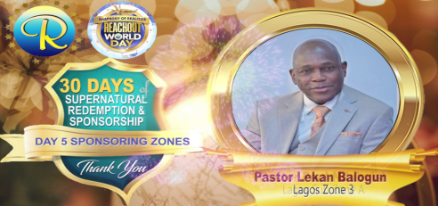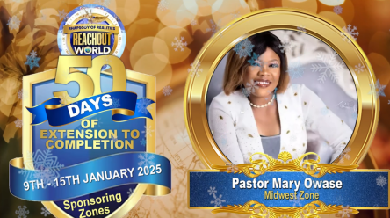
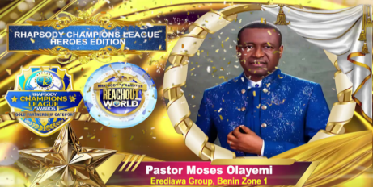
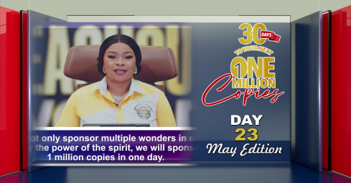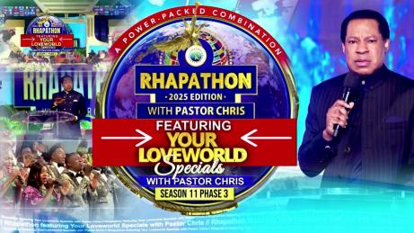

Kindly find just a fraction of the links and pictures to attest to the work I did in this ministry year, 2025.Thank you for the Opportunity to serve the Lord Jesus Christ in this capacity.

